KAKINADA 25K MDM CENTRALISED KITCHEN

QUALITY PLAN

At.
The Akshayapatra Foundation,
Kakinada, Andra Pradesh, India

CONTENTS

- Purpose
- Scope
- Aim
- Quality Policy
- Quality Management system
- Roles and responsibilities
- Recommended tools and equipment’s
- Methodology
- Quality Audit program
- Quality checklist
- Kitchen Equipment and Kitchen Utilities Inspection
- Corrective Action and Preventive Action Reports
- Training program
- Continual Improvement
- Storage of records

- Purpose

The purpose of this document is to describe plan required to effectively manage project quality, from project planning to delivery, comprising quality objectives, roles and responsibilities, quality approach to ensure that the quality objectives are achieved at site for Akshaya Patra project.

2.0 Scope

Scope of this document covers the following activities for Akshaya Patra project:
- Objective of the document
- Quality policy and management system
- Roles and responsibilities
- Methodology
  - Mockup, technical data sheets and shop drawing approvals
  - Factory Inspection-Witnessing activities, inspections and tests
  - Material handling and lifting at site
  - Installation procedure
  - Testing and commissioning
- Recommended tools and equipment’s
- Quality audit – Reports and Audit calendar
- Quality Checklists
- Corrective Action and Preventive action reports (CAR & PAR)
- Training program
- Continual Improvements
- Storage of records.

- Aim

The aim of this document is to outline the process to comply with quality expectations and requirements from Akshaya Patra and handing over the project with best quality and with snag free practical completion.

4.0 Quality Policy

To consistently meet and strive to exceed the agreed requirements of Akshaya Patra in the most cost-effective manner by providing a high standard of Management, Technical expertise, Workmanship and handing over the Project with snag free practical completion.

This will be achieved by ensuring supervision from highly professional technical expertise from Client/ Project team, consultants, and vendors as a team, striving towards snag free practical completion.

Quality is one of the important goals for any vendor partner associated with project to deliver high quality Project to meet Akshaya Patra expectation, be operational friendly by establishing a robust QA/QC plan, working methodology and appropriate usage of tools & equipment as mentioned in this document.

5.0 Quality Management system

An established system of Management of Quality is followed aiming to achieve the following:
- Establishing an international standard of work practices.
- Resolving specific problem areas covering technical, product or system issues
- Investigating new methods of work and ideas.
- Revising procedures

This is achieved by proper monitoring, control, and coordination among Akshaya Patra project team/ Consultants and vendors as team.

6.0 Roles and Responsibilities

RESPONSIBILITY MATRIX
DESCRIPTION | TAPF Central Project Team | Regional Project / PMC | ARCHITECT | MEP CONSULTANT | VENDORS
PRE-CONSTRUCTION STAGE
Make of Materials | I | C | A | A | NA
Define Quality Management Plan | I | A | C | C | NA
Tender Document Submissions | R | R | A | A | NA
Tender document Verification | A | R | C | C | NA
Design and Detail Drawings | R | R | A | A | NA
CONSTRUCTION STAGE
Monitoring Execution | A | R | C | C | R
Implementation and Signoff on Quality Checklist | I | A | C | C | R
Approval of Samples / Make of Materials | C | C | A | A | R
Approval of Mock-up | C | C | A | A | R
Material/Work Inspections | I | A | I | I | R
Factory Test-Witnessing and testing | C | R | NA | R | A
Third Party Testing’s as per QCP | C | R | NA | NA | A
Daily Issue of Quality NC/ Site note Report | I | A | NA | NA | R
Daily Closure of Quality NCs | I | R | NA | NA | A
Periodic Quality Joint Walkthrough with all Consultants | C | A | A | A | A
Weekly Quality Report by Consultants | I | A | NA | NA | NA
Closure of Consultant Report | I | A | C | C | R
Weekly Quality Inspection by PM | I | A | NA | NA | R
Weekly Quality Field Report | I | A | NA | NA | R
Closure of Points of Weekly Quality Field Report with Photographs | I | A | NA | NA | R
Monthly Quality Review Meeting | I | A | C | C | A
Quality Checklist Review | I | A | C | C | R
Closure of Quality Checklist Observations | I | A | C | C | R
POST-CONSTRUCTION STAGE
MEP Testing & Commissioning Witness | C | A | I | I | R
Demo & Training to AP Team | C | A | I | I | R
Work Completion | C | A | I | I | R
LEGEND: I - Information, A - Accountability, R - Responsibility, C - Contribute, NA - Not Applicable

Project team Responsibility:

- Ensure that the activities are carried out according to the specifications, drawings, and approved method statement
- Ensure that all submittals are made in a timely manner
- Arrange all materials and tools required for installation as per agreed project schedule which are dust free generating and environmentally friendly.
- Provide all necessary information and distribute the responsibilities to the vendors
- Monitoring of all quality test are carried out by all vendors and obtained approval from consultants
- Monitoring and ensuring that the work is performed in accordance with the technical specifications, approved methodology and shop drawings.
- Conduct quality audits on regular need basis in coordination with consultants/ third party consultants and raise corrective action reports (CAR) in case of non-compliance in adhering to quality as per technical specification, standards, and approved shop drawings.
- Review and closure of the CAR’s along with preventive action reports (PAR’s). And closure of audit reports.
- Ensure and support vendor to provide proper trainings to their workmen

Architect/ Consultants Responsibility:

- Ensure that the activities are carried out according to the specifications, drawings, and approved method statement
- Ensure that all submittals are approved in a timely manner
- Recommend all materials and tools required for installation as per agreed project schedule which are dust free generating and environmentally friendly.
- Witnessing tests that are carried out and provide approvals.
- Monitoring on regular basis and certify that the work is performed in accordance with the technical specifications, approved methodology and shop drawings.
- Conduct quality audits on regular need basis in coordination with client project team/ third party consultants and raise corrective action reports (CAR) in case of non-compliance in adhering to quality as per technical specification, standards, and approved shop drawings.
- Review and closure of the CAR’s along with preventive action reports (PAR’s). And closure of audit reports
- Ensure and support vendor to provide proper trainings to their workmen in coordination with client project team.

Vendors Responsibility:

- Adherence of Quality Management Plan by each vendor based on the respective scope of work.
- Deployment of Well experienced dedicated Quality Engineer for the project.
- Evaluation the design in collaboration with the consultant’s team and conclude the same.
- Provide sample submission for the selection of appropriate materials
- Submission of Multipoint method statement by working out detailed execution methodology for each activity.
- Ensure necessary mockup is executed & approved prior to commencement of actual scaling.
- Using appropriate Tools & Equipment’s for respective works including to demonstrate quality of materials.
- Periodic checking and calibration of testing equipment
- Deployment of trained & experience sub-vendors/Technicians/Workforce.
- Control of non-conforming works, monitoring and continual improvement
- Ensure necessary Work checklists (listed below) implementation as per TAPF standard
- (Client project team, C&I, MEP Managers and Stakeholders) prior to commencement and post completion of respective works
- No work shall be performed without Client project team signoff of relevant checklists.
- Ensure Ventilation, illumination, humidity, and temperature conditions meet the job specific requirements prior to any work commencement.
- Quality audit shall be conducted by Client project team /Architect/Design Consultants during construction stage of the project

7.0 Recommended tools and equipment’s:

7.1 Recommended tools:

Following tools are recommended for this project which indicates the current practice generally followed at site to the recommended practices primarily to aim at the best quality of the finishes, snag free practical completion along with best working environment without any dust generation at site. The vendor needs to consider these tools and tackles into consideration mandatorily while execution at site

Sr.  No. | Classification of recommended tools | Application
1 | Measuring and levelling | All trades
2 | Power tools | All trades
3 | Surface finishing tools | Civil and interiors trade - Solid Acrylics, painting & polishes
4 | Surface preparation tools | Civil and interiors trade – Dry Walls, ceiling, and flooring

Sl. No. | Activity | Conventional practice | Recommended practice
Measuring and levelling tools
1 | Chalk line marking | 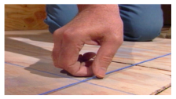 | 
 |  | Line Dori | Chalk Box
2 | Partition marking and workstation marking | 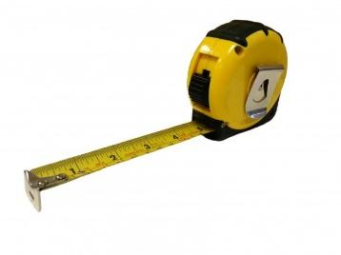 | 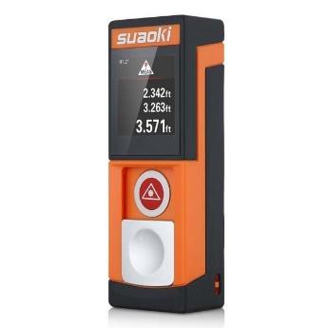
 |  | Measuring Tape | Laser Distance Meter
3 | Levelling | 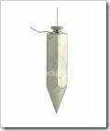 | 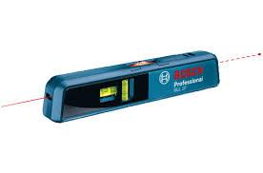
 |  | Plumb Bob | Laser Levellers
4 | Tile Levelling | 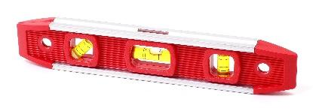 | 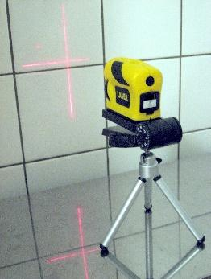
 |  | Conventional Level Marking | Laser Tile Leveler
5 | Grid ceiling alignment and levelling | 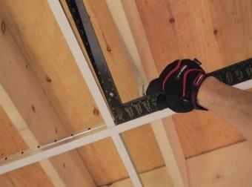 | 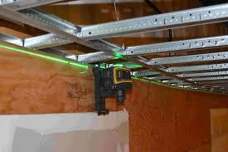
 |  | Conventional Levelling | Laser Ceiling Alignment and Levelers
Cutting Chipping and Drilling Tools
6 | Gypsum ceiling cutting |  | 
 |  | Handsaw | Jab Saw
7 | Gypsum saw |  | 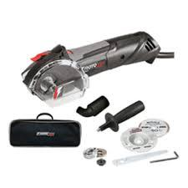
 |  | Handsaw | Roto Zip [Rotating cutter] with vacuum provision
8 | Tile cutting | 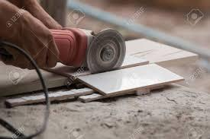 | 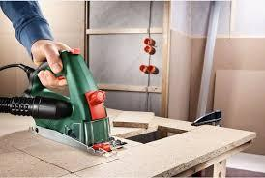
 |  | Angle Grinder | Tile Cutter with Vacuum Provision
9 | Block cutting | 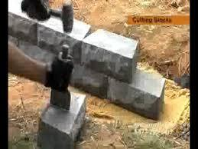 | 
 |  | Conventional Block Cutter | Block Cutter with Vacuum provision
10 | GI stud cutter |  | 
 |  | Conventional Cutter | Metal Cutter
11 | Ply stud cutting | 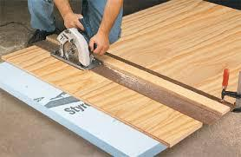 | 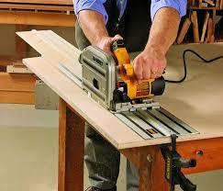
 |  | Conventional Cutting | Sawhorse, Circular Saw with Vacuum provision
12 | Raceway / pipe / metal cutting |  | 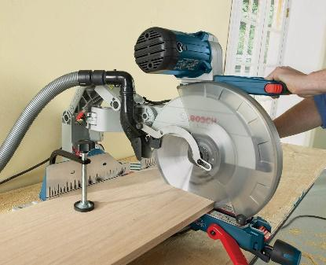
 |  | Cutting Saw with Adhesive Wheel | Metal Cutting Saw with vacuum provision
13 | Floor chipping |  | 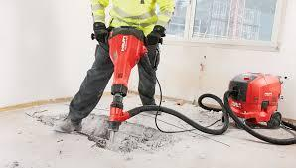
 |  | Floor Chipper | Floor Chipper with DRS
14 | Access floor tile cutting |  | 
 |  | Conventional Tile Cutter | Access Floor Tile cutter with Vacuum Provision
15 | Mortar mixing | 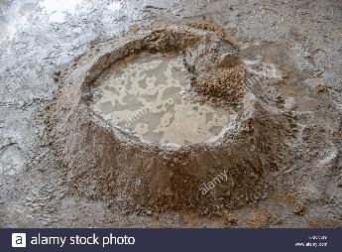 | 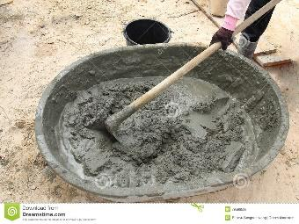
 |  | Conventional Mixing | Mixing Pan for Mixing
16 | Wall chipping | 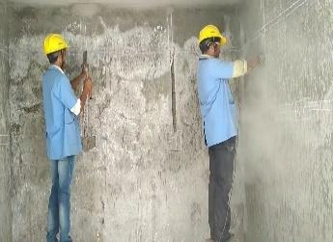 | 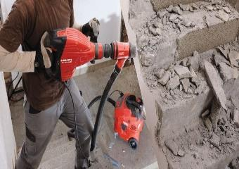
 |  | Chipping Machine | Chipping Machine with Vacuum Provision
17 | Ceiling / wall drilling |  | 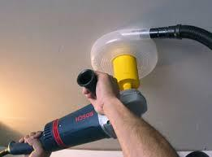
 |  | Conventional Drilling | Drilling Machine with Vacuum Provision
18 | Ceiling / wall grinding | 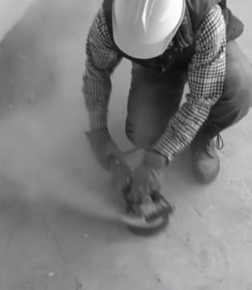
 |  | Conventional Grinding Machine | Angle Grinder with vacuum Provision
19 | Drywall joint finish | 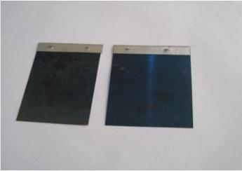 | 
 |  | Joint Finish Blade | Joint Finish Blade (3 sizes for 3 layers of joint)
20 | Board screw fixing machine | 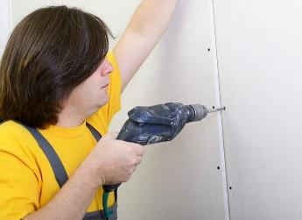 | 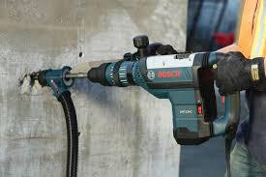
 |  | Screwing Machine | Screwing Machine with Dust Extractor
21 | Gypsum ceiling sanding |  | 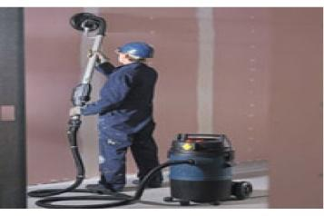
 |  | Sanding using Sandpaper | Sanding Machine with Vacuum Provision
22 | Floor / ceiling grinding
 |  | Conventional Grinding Machine | Angle Grinder with vacuum Provision
23 | Marble / granite / Corian polishing works | 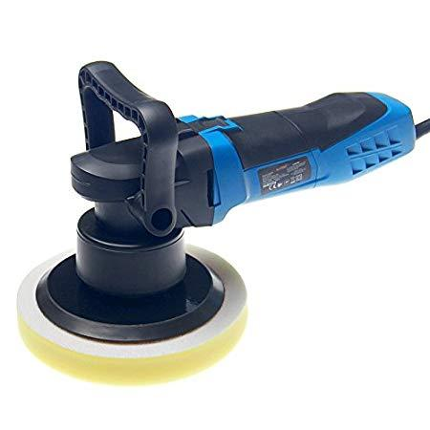 | 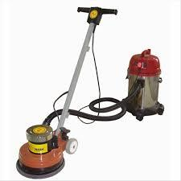
 |  | Conventional Polish Machine | Polish Machine with Vacuum
24 | Paint mixing | 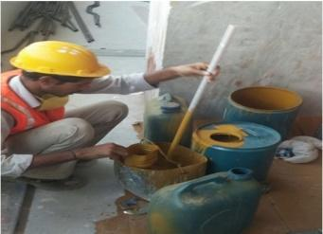 | 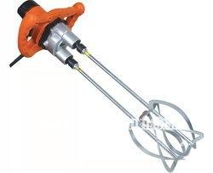
 |  | Hand Mixing | Electric Mixer
25 | Tile grouting | 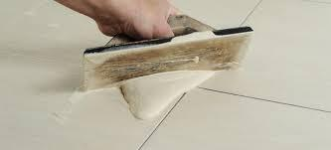 | 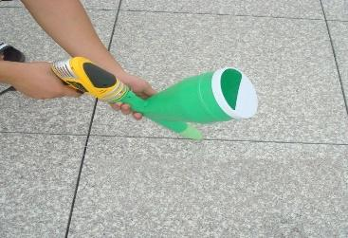
 |  | Conventional Grouting | Grouting Gun
26 | Modular glass installation | 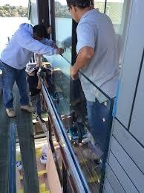 | 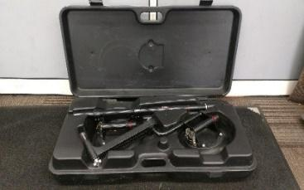
 |  | Conventional | Required Tools for Modular Glass Installation
27 | Carpet laying | 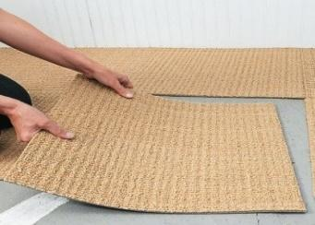 | 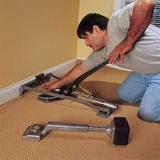
 |  | Conventional | Required Tools for Carpet Laying

7.2 Recommended equipment (testing and measuring):

Following equipment’s are recommended for this project to be followed at site primarily to aim at best quality and achieving the test results as per design towards testing Current & Voltage values, Air Flow and Temperature Calibration. The vendor needs to consider this equipment’s into consideration mandatorily while execution at site.

7.2.1 Testing and measuring equipment– Current and Voltage values

- Electrical Multimeter
- Thermal Imaging camera
- Clamp meter
- Live Earth Tester
- Lux Meter
- RCD Tester
- Power Quality Analyzer
- Polarity Tester
- Phase Sequence meter
- Crimping Tool

7.2.2 Testing and measuring Equipment – Air flow and temperatures

- Anemometer
- Hood Meter
- Hood Meter
- Decibel Meter
- Digital Tachometer
- Smoke Tester
- Duct Leakage Tester
- Copper pipe brazing torch
- Psychomotor

7.2.3 Testing and measuring Equipment – Firefighting services

- Pressure Booster.

The vendor should note that the above list is tentative while project specific equipment requirements are to be taken care of by the respective vendors on need basis.

Recommended equipment’s list:

7.2.1 Testing and measuring equipment– Current and Voltage values

Sl. No. | Equipment | Purpose | Recommended practice
1 | Electrical Multimeter | Check Voltage value | 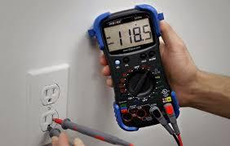
2 | Thermal Imaging camera | Check hotspots in terminations | 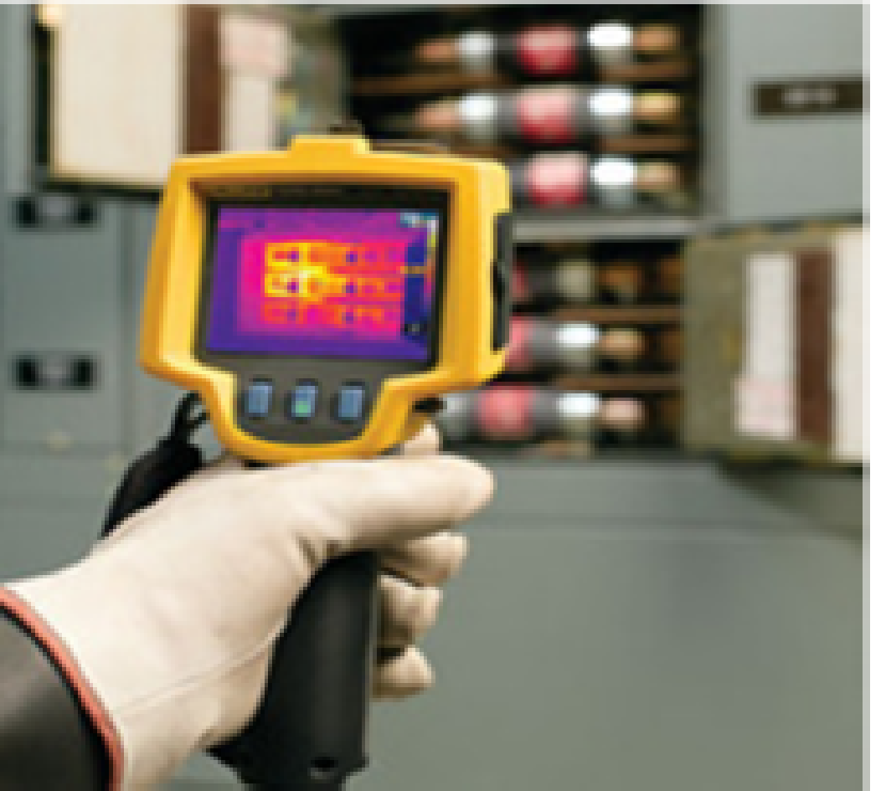
3 | Clamp meter | Check current(I) Value | 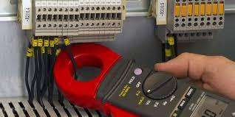
4 | Lux meter | Check Lux value | 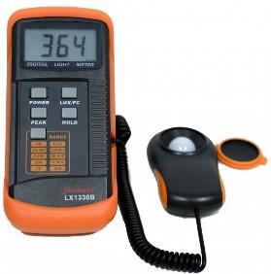
5 | RCD Tester | Check RCD and RCD Tripping time | 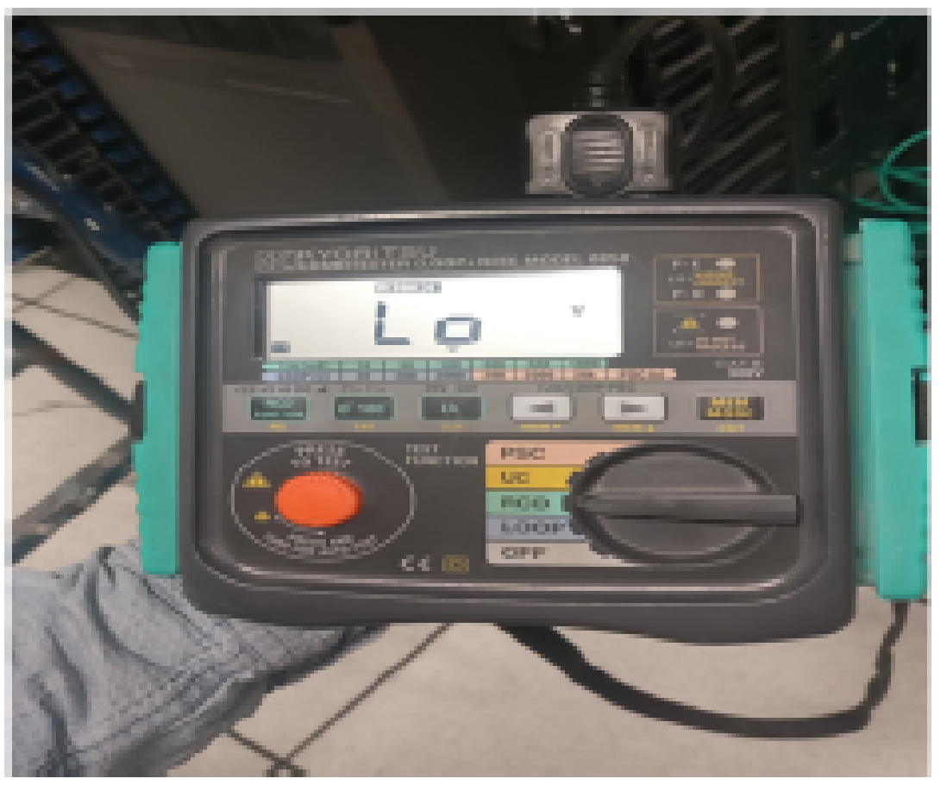
6 | Power Quality Analyzer | Check power Output values | 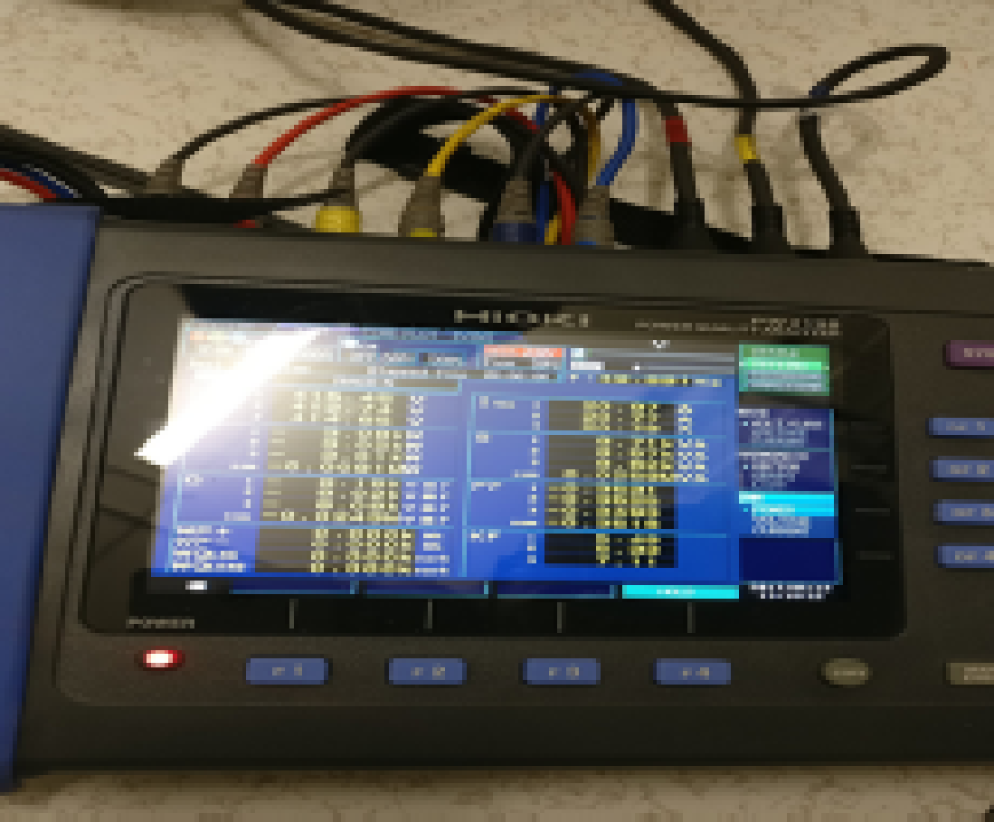
7 | Polarity Tester | Check power sockets | 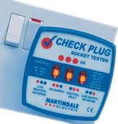
8 | Phase Sequence meter | Check phase sequence of 3 phase supply | 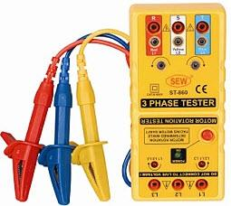
9 | Crimping Tool | To crimp lug with cables | 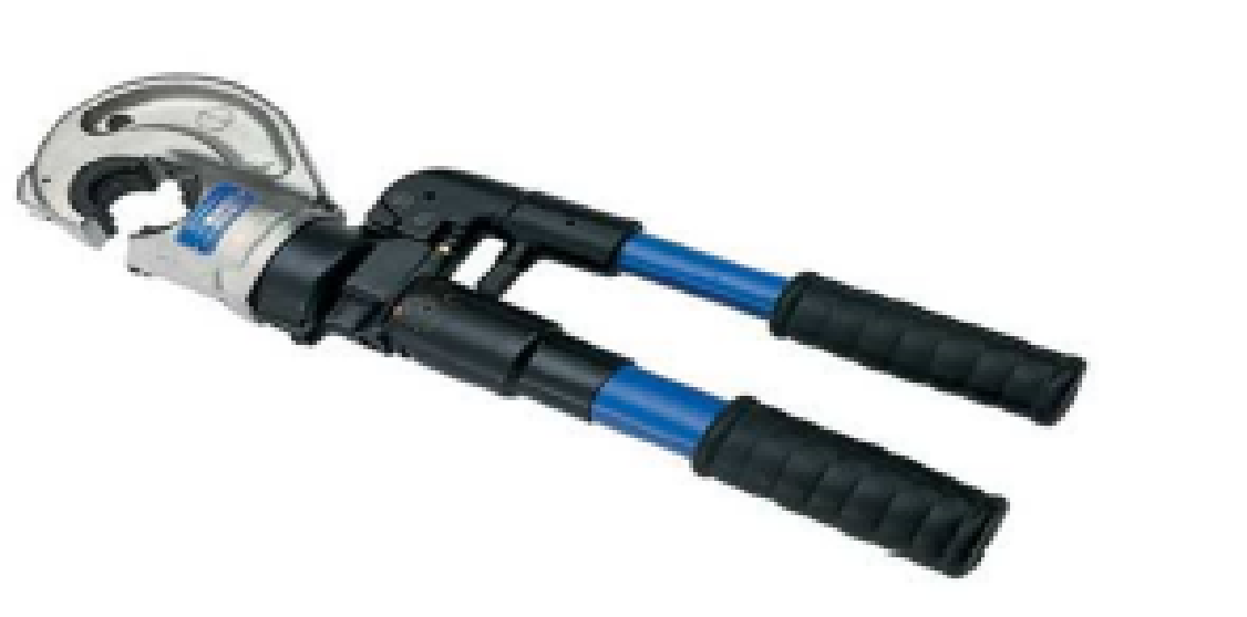

Testing and measuring Equipment – Air flow and temperatures

Sl. No. | Equipment | Purpose | Recommended practice
1 | Anemometer | Check Air flow through Grills | 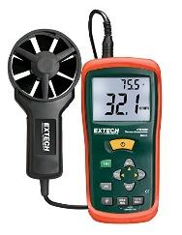
2 | Hood Meter | Check air flow inside closed cabins through diffusers | 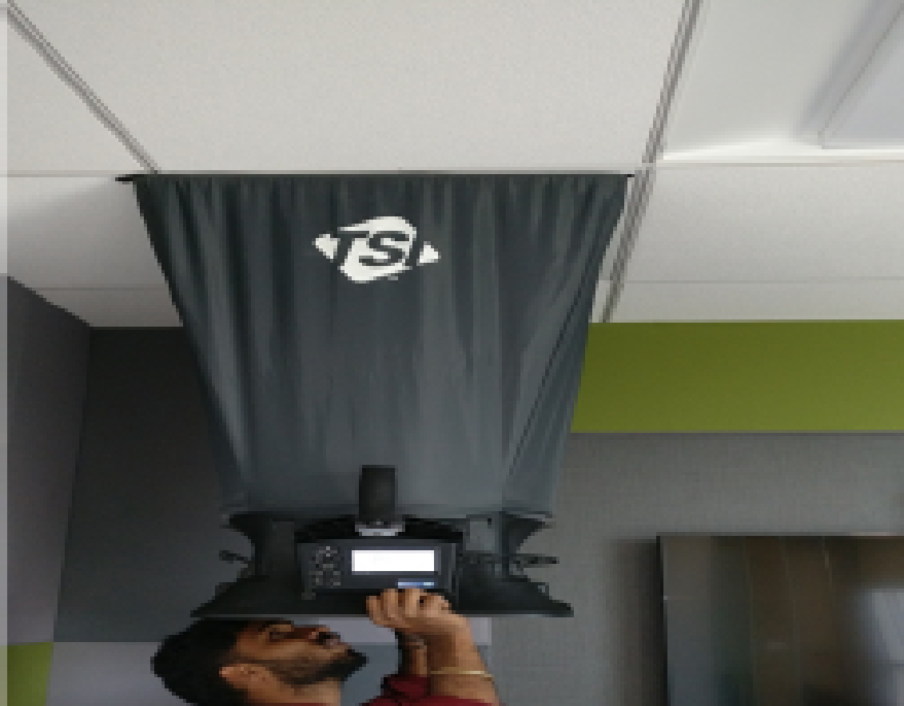
3 | Decibel Meter | Test Sound level | 
4 | Digital Tachometer | Check speed/ RPM of machines  (AHU Motor) | 
5 | Smoke Tester | Check air leaks from ducts | 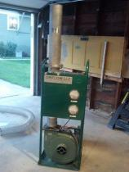
6 | Duct Leakage Tester | Check air leakage from ducts | 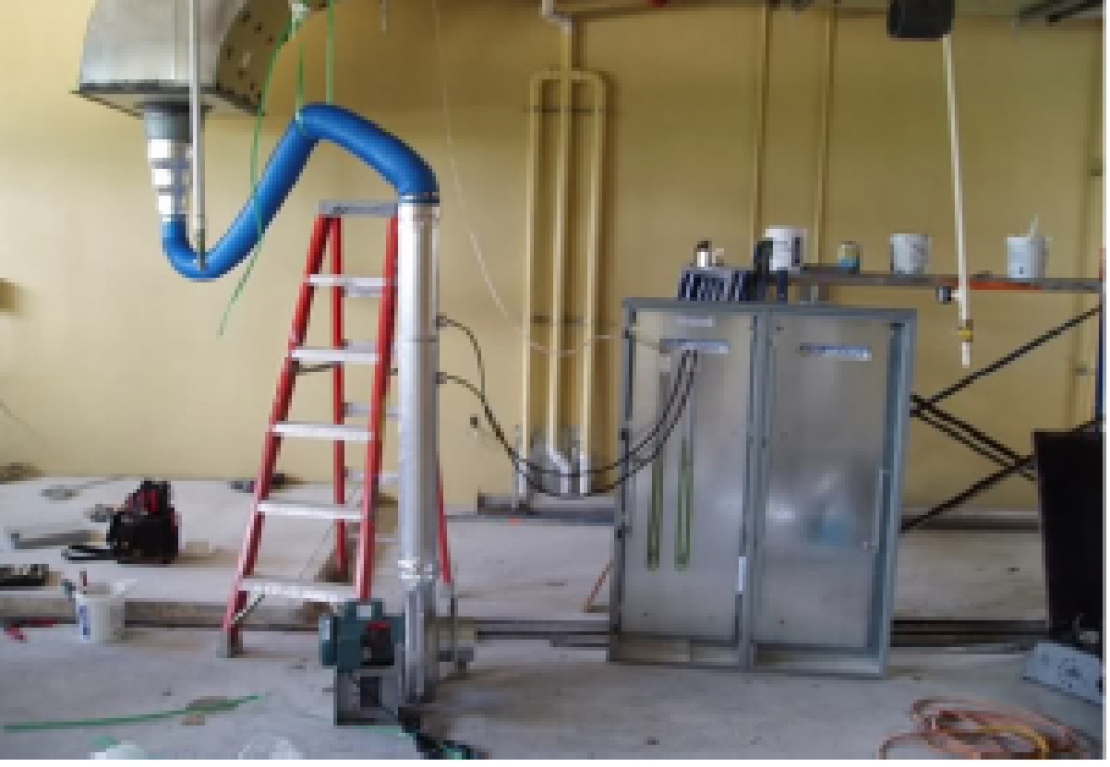
7 | Copper pipe bracing torch | Welding of Copper pipes | 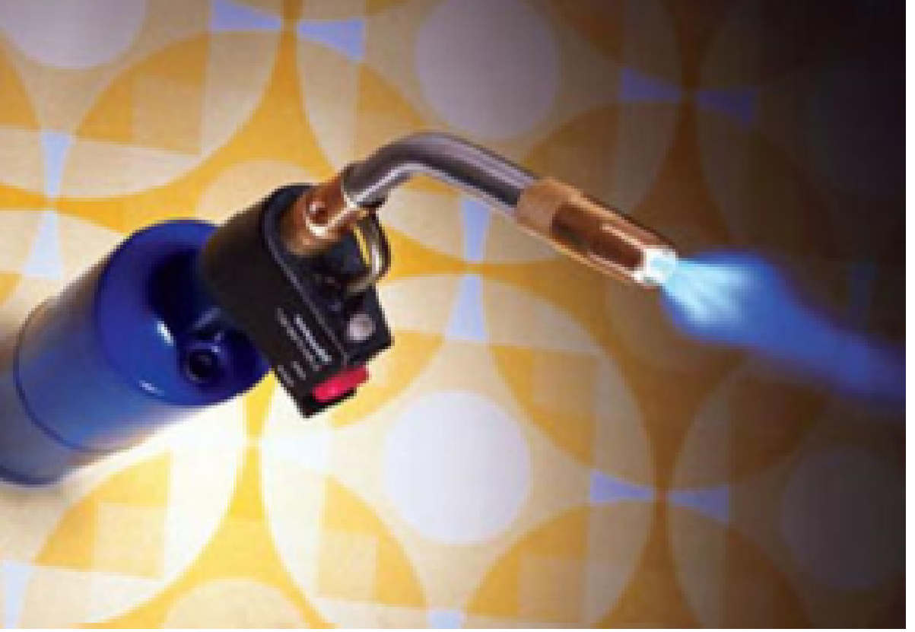
8 | Psychomotor | Check wet and dry bulb temperature | 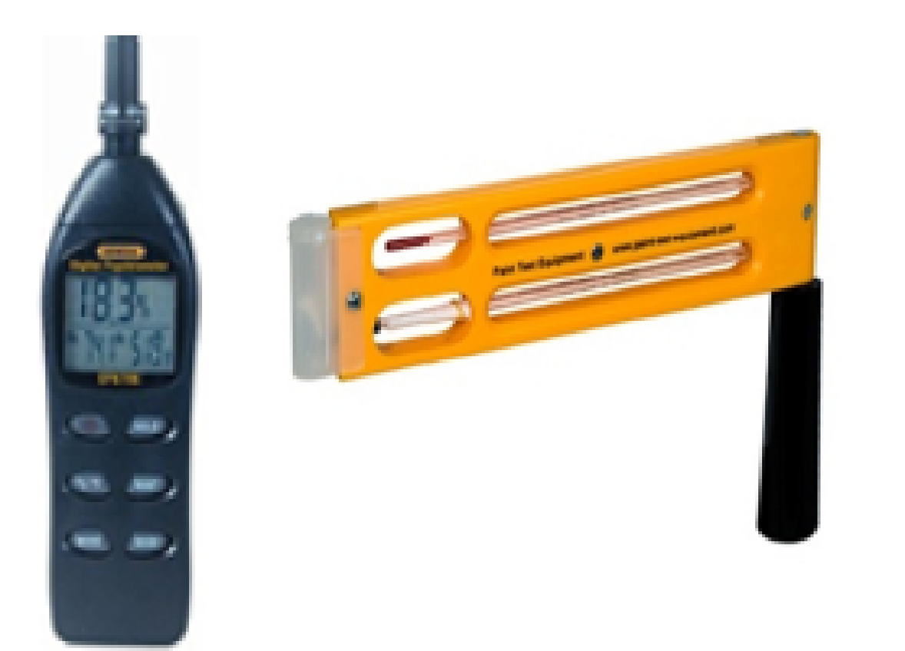

8.0 Methodology

  - Mockup, technical data sheets and shop drawings approvals

Vendor to submit samples of materials for mock-up technical data sheets and shop drawings prior to the start of any work and will be got approved from AP Project team/Architect/ consultant as per agreed technical specifications and boq. Vendors need to submit the work methodology for all the tasks and need to get it approved from Client project team /consultant/architect before commencement of the works.

8.1 Factory Inspection of equipment’s/ materials

- Client project team / Consultant will visit, witness, and carry out factory inspection test at OEM’s/vendors factory as per the standard testing procedure mentioned in the checklist complying with agreed technical specification, makes and approved shop drawings.
- Post approval by Client project team /Consultant on the factory test conducted and clearance, vendor shall initiate to deliver of materials to site.

8.2 Receipt and storage of material

- The materials shall be offloaded in the designated location (in weatherproof place) in original packing as far as possible
- The permissible storage temperature shall be ensured to maintain as mentioned in the OEM’s instruction manual
- It shall be ensured that protection of equipment’s/ materials against damage

8.3 Installation Procedure for equipment’s/materials
- Before installation, the concerned area shall be clean and free from dust
- Method statement containing the technical details such as handling capacities and lifting procedures of lifting equipment, along with the rope dia., to be approved by Client project team / Design Consultant before initiating installation activity
- Post approval on the work method statement, the pallets containing the equipment’s /materials shall be removed from the vehicle and to be placed temporarily in the corridor as close to the respective loading room as possible in order to avoid unnecessary ways by using the lifting equipment.
- Ropes shall be attached far enough on the hoisting tackle so that they cannot exert any forces on equipment/ materials to be shifted
- The ropes shall be slung around the ends of the wooden pallet
- It shall be ensured that nobody is standing in the swinging area of lifted equipment/materials.
- Unload the transport units in packed condition and leave packed as long as possible
- After unloading all pallets in the temporary place, each pallet shall be dismantled carefully to take the subject materials out
- Using forklift, equipment’s/ materials (that need to be shifted) will be placed on the material hoist and will be lifted to the respective floor
- From the floor, the equipment’s/materials will be shifted to the respective location using forklift/ HPT
- While moving through the corridor and inside the room, it shall be ensured that materials should not hit the side walls and other panels already installed in the room
- While positioning the equipment’s/materials, it shall be ensured that the installation is done as per the approved shop drawings

8.4 Installation:

The installation has to be carried out as per the standard checklist provided in this document and as per the work methodology specified in the technical specification document.

8.5 Stock Inspection

- Mechanical Inspection:
  - Ensure no physical damage internal or external for all the equipment/materials and incorporate in the checklist
- Electrical Inspection
  - Ensure the size of power cable for equipment’s such as UPS input, output, bypass and battery cabinets, Precision Air conditioning units, Panels etc., are per technical specifications.
  - Ensure voltage measurements such as UPS input, output, bypass and battery cabinets, Precision Air conditioning units, Panels etc., are per technical specification

8.6 Testing and commissioning Procedure

The testing and commissioning has to be carried out as per the standard checklist provided in this document and as per the work methodology, testing and commissioning checklist as specified in the technical specification document.

Further all the above documents need to be read in conjunction with respective to tender specification and boq.

For above mentioned procedure all necessary PPE and safety gear should be always worn during the execution of work, in full compliance with safety guidelines as specified in the safety plan document
- Helmets
- Safety Shoes
- Hand Gloves
- Safety Signs
- Reflective Vest

Safety checks will be made prior to commencement of work in order to ensure that materials and equipment are in safe working order in accordance with project and site guidelines as specified in the safety plan document.

9.0 Quality Audit program:

The audit program will cover the following categories of audits.
- Internal Audits program of Client project team/Consultant
- External Audits where appropriate
- All quality audits whether internal or external, will be carried out in accordance with the quality system auditing procedures. These procedures will also cover the distribution of reports and method of follow up and close out of findings.
- Client project team will have a thorough surveillance and regular site inspections to ensure that contractors are performing to the required standards so as to deliver a high-Quality product as per the contract, Specifications.

Internal audit of Client project team/Consultant will cover the following:

- Site surveillance, visual inspection or inspection with use of suitable instruments, of the works completed and/or under progress, perusal of photographic record, if any.
- Perusal of quality control and quality assurance (QC/QA) documentation, and all test records and registers.
- Inspection of testing laboratories, adequacy of testing facilities, and reliability thereof and general competence of laboratory staff.
- Contractor's workforce and construction equipment deployed at works and assessing the adequacy thereof in respect of the quality related aspects.
- Whether any corrective/preventive actions are needed and being implemented.
- Ensuring and adherence of quality work list as mentioned in this document from vendors

Quality audit shall be conducted as per the program mentioned below by consultant’s/ Client project team to ensure compliance of technical specification, approved shop drawings, approved samples are executed by vendor for achieving towards sang free practical completion.

Sl. No. | Description | Periodically | Periodically
1 | Internal Audits by Client project team /Consultants | √
2 | External Audits by Central Projects /Appointed Agency |  | √

10.0 Quality checklist:

Attachment:

      - General Quality Control Plan

The above checklists are attached with this quality plan document and should be read in conjunction with the technical specifications, bill of quantities, approved samples, and shop drawings.
The above checklists and guidelines have to be adhered at site by concerned contractors. Implementation of checklist should be done by contractor which shall be witnessed and approved by TAPF Engineer/PMC.

11. Kitchen Equipment and Kitchen Utilities Inspection

List of Kitchen Equipment items which shall be jointly inspected (Vendor and Client) at site while the time of delivery. Vendor has to make the necessary arrangements for the material/equipment inspection. Necessary drawing and details of issued PO also should be available with the vendor.

Apart from the below list of kitchen equipments, in case if client wishes to have factory inspection including above listed equipments, vendor to provide necessary supports. In case of any defects found apart from the below items, vendor the take the necessary actions as per terms & Conditions
- Rice Cleaning Machine
- Roti Machine
- Conveyers
- Steam Generated units
- Cold Room
- Any customized machines (like Vessel washing etc.)
- Silo’s – Storage
- Lifts – Passenger and Goods
- Kitchen Utilities like – ETP, DG, RO, HVAC, Fire Fighting, LOT Gas, Solar (Hot water and PV) systems, Boiler and Accessories etc.
Note: This section (Section-11) may not be applicable to Civil Contractor. This is for internal team reference.

12. Corrective Action and Preventive Action Reports:

The root causes of all findings will be investigated, and the trends examined to enable corrective action to be taken to prevent recurrence as per the below mentioned format:
NOTE: NC FORMAT TO BE FOLLOWED

12.0 Training program:
Sl. No. | Description | Daily | Monthly | Quarterly
1 | Toolbox training | ●
2 | Best practices- Display of videos of all trades |  | ●
3 | Technical training – specific trade package. |  |  | ●

13.0 Continual Improvement:
Conduct Training program
- Identify the personnel required to perform work affecting quality product based on the following criteria:
    - Discipline
    - Functional experience and skills
- Identify gaps that will affect Quality and give appropriate training
- Evaluate effectiveness of training and monitor.
14.0 Control of records
All the documents and records need to be properly filed and storage in a safe manner before handing over to Akshaya Patra. Client project team to ensure to maintain list of documents in google drive along with all supporting documents. All the hard copies related to quality need to be filed as a separate document at site and shall hand over to Akshaya Patra team as part of handing over.

